Smelling Parkinson’s Disease

Introduction
As reported by the Washington Post, Joy Milne of Perth, UK, smelled a “subtle musky odor” on her husband Les that she had never smelled before. At first, Joy thought maybe it was just from the sweat after long hours of work. But when Les was diagnosed with Parkinson’s 6 years later, Joy suspected the odor might be a result of the disease.
Scientists were intrigued by Joy’s claim and designed an experiment to test her ability to “smell Parkinson’s.” Joy was presented with 12 different shirts, each worn by a different person, some of whom had Parkinson’s and some of whom did not. The shirts were given to Joy in a random order and she had to decide whether each shirt was worn by a Parkinson’s patient or not.
- Why would it be important to know that someone can smell Parkinson’s disease?

- How many correct decisions (out of 12) would you expect Joy make if she couldn’t really smell Parkinson’s and was just guessing?

- How many correct decisions (out of 12) would it take to convince you that Joy really could smell Parkinson’s?

Simulating the Experiment
Although the researchers wanted to believe Joy, there was a chance that she may not really be able to tell Parkinson’s by smell. It’s logical to be skeptical of claims that are very different than our experiences. If Joy couldn’t really distinguish Parkinson’s by smell, then she would just have been guessing which shirt was which. The researchers were not willing to commit time and resources to a larger investigation unless they could be convinced to that Joy’s wasn’t just guessing. When researchers have a claim that they suspect (or hope) to find evidence against, it’s called the null hypothesis.
- What claim were the researchers hoping to find evidence against? That is, what was their prior belief (null hypothesis) about the ability to smell Parkinson’s?

- What claim were the researchers hoping to find evidence for? This is called the alternative hypothesis or the research hypothesis.

To investigate the idea that Joy was just guessing which shirt was worn by which type of person, we will begin by assuming that the null hypothesis is true.
- Your group will get 24 cards. Randomly deal out 12 cards to each pair. Don’t turn them over yet! On the back of some of them is “Parkinson’s” and on the back of others is “None”
- One person in the pair will smell and guess each of the 12 cards. The other person will record whether they were correct or not in the table below.
- Reshuffle the group’s cards and repeat this for the other person in the pairs.

Student Name | Tally of correct identifications | Tally of incorrect identifications

- Create a dotplot of the number of correct identifications in our class:

0
2
4
6
8
10
12

- In the actual experiment, Joy identified 11 of the 12 shirts correctly. Based on the very small-scale simulation by you and your classmates, what proportion of the simulations resulted in 11 or more shirts correctly identified, assuming that the person was guessing?

- The proportion you just calculated is a crude estimate of a true probability called a p-value (short for probability-value). How might we improve our estimate of the true probability?

Statistical Inference from the Simulation
- Use this web site to run a simulation of this activity 10,000 times: https://www.lock5stat.com/StatKey/

Choose “Confidence Interval for a Proportion.” Then choose “Edit Data” and enter 5 AND 10 for the count and sample size. Then run this simulation 10,000 times. Change the dotplot display from “Proportion” to “count.”
This shows what the distribution looks like IF Joy was simply guessing.
This should be a better estimate of the p-value for 11 or more shirts correctly identified, assuming that this person was just guessing.
Is it possible that Joy correctly identified 11 shirts just by random chance (guessing)? Is it likely?
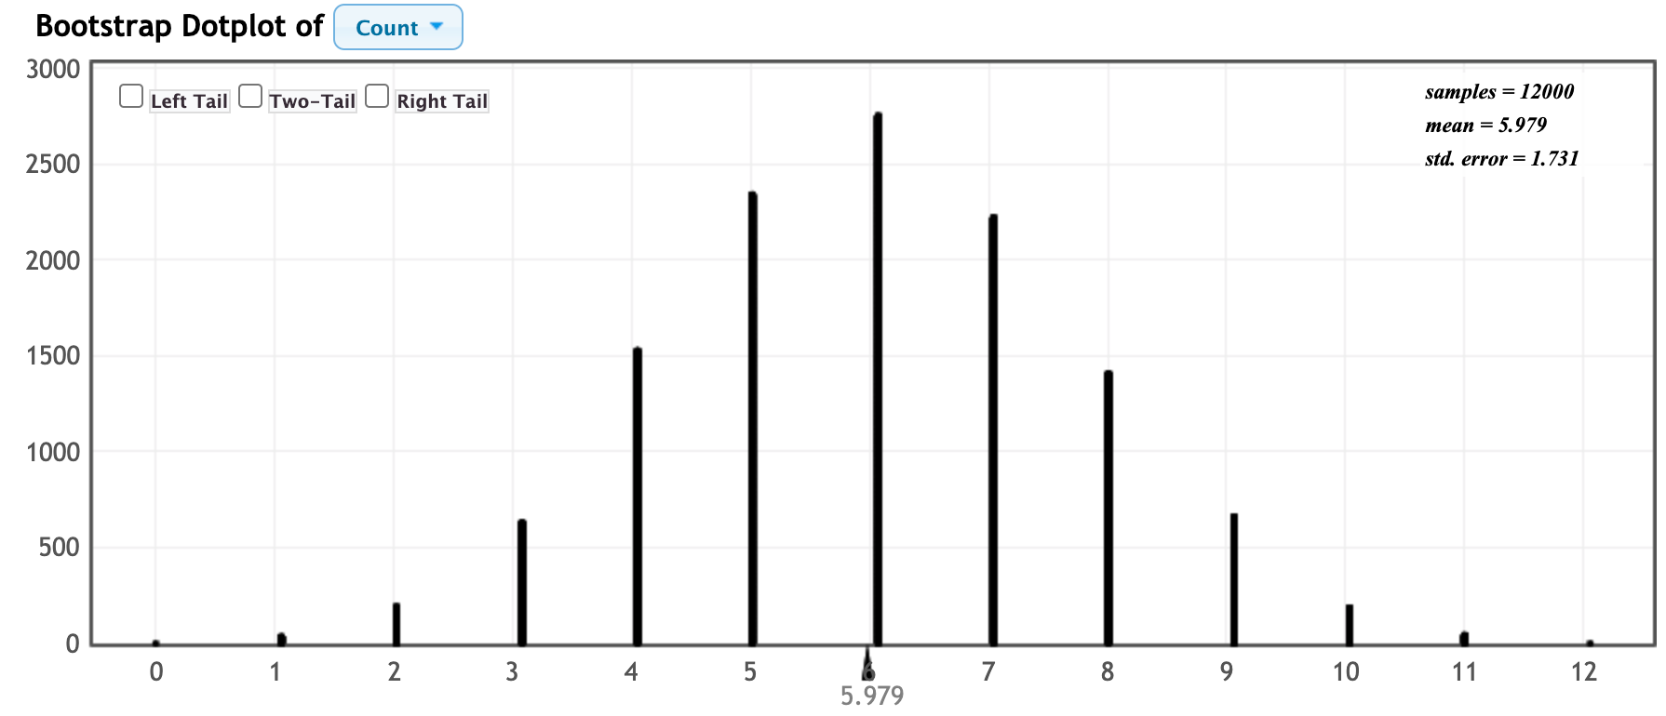

- An interesting side note is that Joy’s one “mistake” really wasn’t a mistake. The shirt was worn by a person who supposedly didn’t have Parkinson’s even though Joy claimed that she could smell the telltale smell on that shirt. That person called the experimenters 8 months after the experiment and reported that he had just been diagnosed with Parkinson’s disease. That meant that Joy correctly identified 12 out of 12 shirts. What is the approximate p-value for 12 shirts correctly identified, assuming that this person was just guessing?

Note: A small p-value is considered strong evidence against the null hypothesis and in favor of the alternative hypothesis. But how small is small? As a rule of thumb, statisticians generally agree that p-values below 0.05 provide pretty strong evidence against the null hypothesis. Observed results with small p-values are said to be statistically significant.

